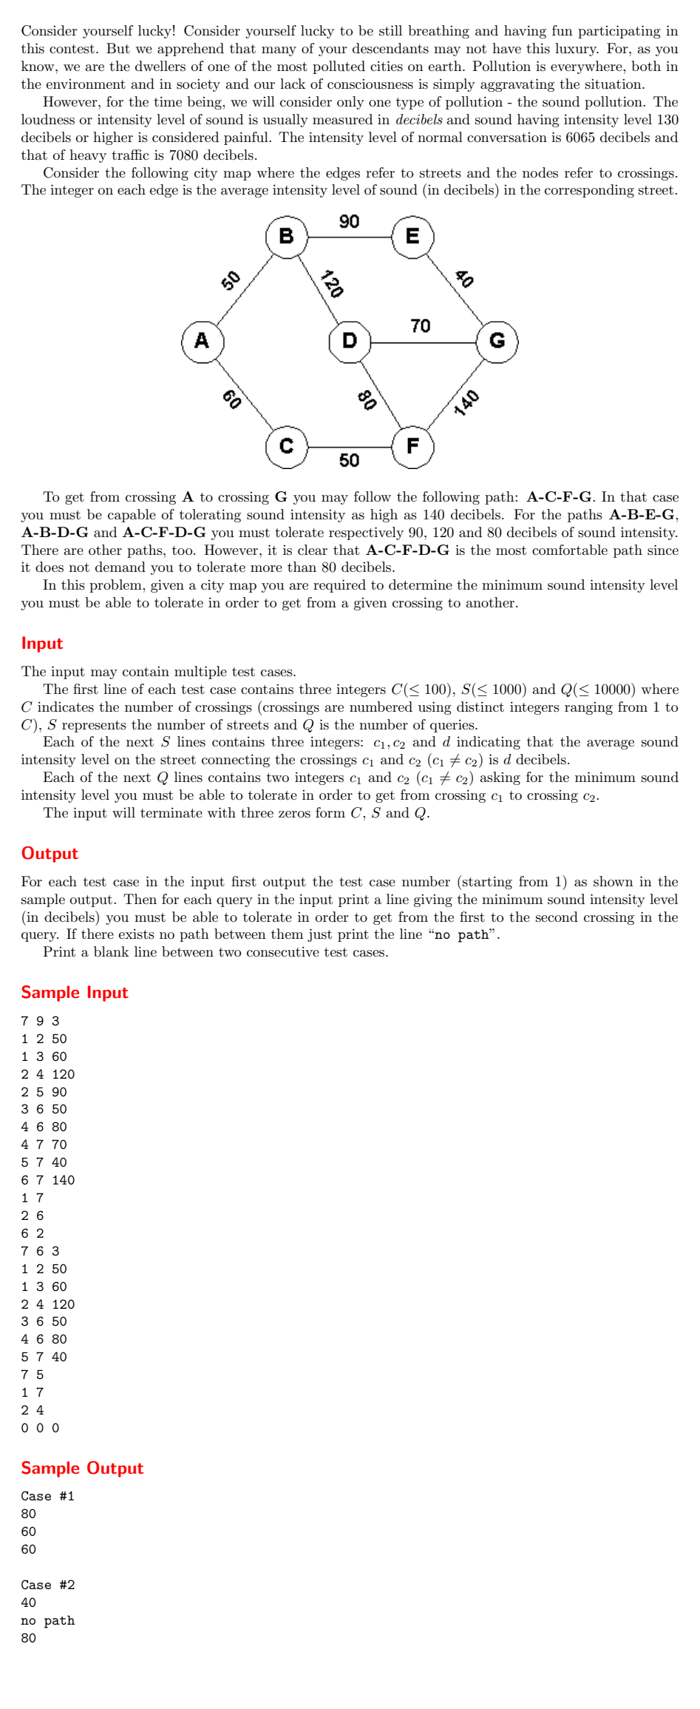
Problem No:
Problem Statement:

Codes:
#include <bits/stdc++.h>
using namespace std;

const int INF = 1e9;

int _minmax[101][101];

int main()
{
int C, S, Q;
int case_num = 0;
while (cin >> C >> S >> Q, C != 0)
{
case_num++;
if (case_num > 1)
cout << endl;

for (int i = 1; i <= C; i++)
{
for (int j = 1; j <= C; j++)
{
_minmax[i][j] = INF;
}
_minmax[i][i] = 0;
}

for (int i = 0; i < S; i++)
{
int c1, c2, d;
cin >> c1 >> c2 >> d;
_minmax[c1][c2] = min(_minmax[c1][c2], d);
_minmax[c2][c1] = min(_minmax[c2][c1], d);
}

for (int k = 1; k <= C; k++)
{
for (int i = 1; i <= C; i++)
{
for (int j = 1; j <= C; j++)
{
int temp = max(_minmax[i][k], _minmax[k][j]);
if (temp < _minmax[i][j])
{
_minmax[i][j] = temp;
}
}
}
}

cout << "Case #" << case_num << endl;

// Process queries
for (int i = 0; i < Q; i++)
{
int u, v;
cin >> u >> v;
if (_minmax[u][v] == INF)
{
cout << "no path" << endl;
}
else
{
cout << _minmax[u][v] << endl;
}
}
}
return 0;
}

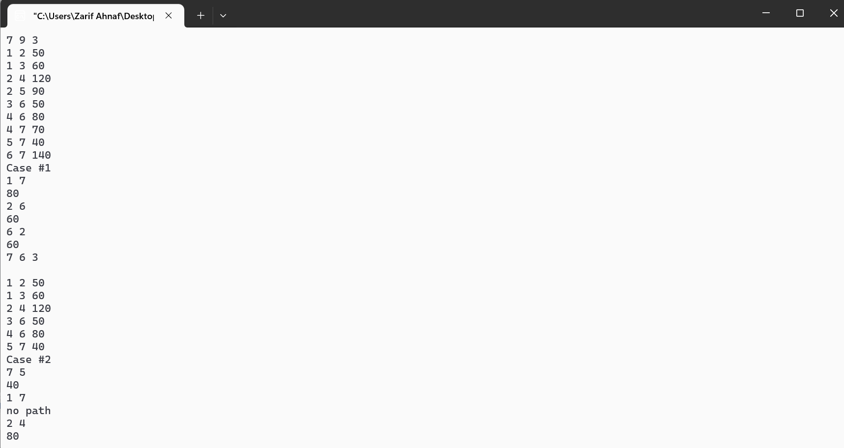
Output:

